April/May 2018 Newsletter
Bizzy Bodies Fitness
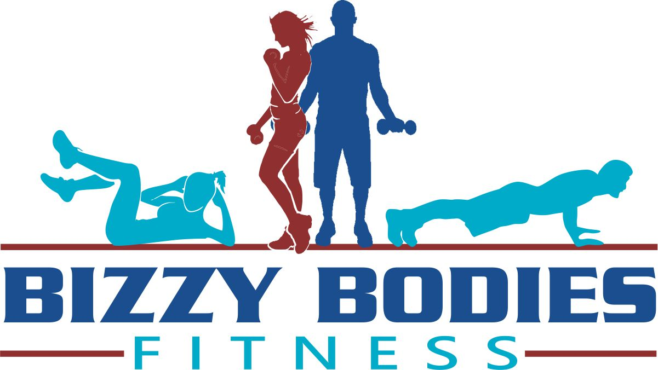

Important Announcement
All FUNdamentals of Fitness Workouts are the same pricing regardless of the location. (See pricing below class schedule). You must continue to sign up for single location six week sessions to get the discounted rate. There must be at least 6 participants signed up for the class to be held. All classes are open for drop ins, please bring your own yoga mat and water.
If you would like to be included on the email list to receive periodic updates on classes and specials, visit the website and click “subscribe”, once you enter your email address you will be added to the list. It’s that easy!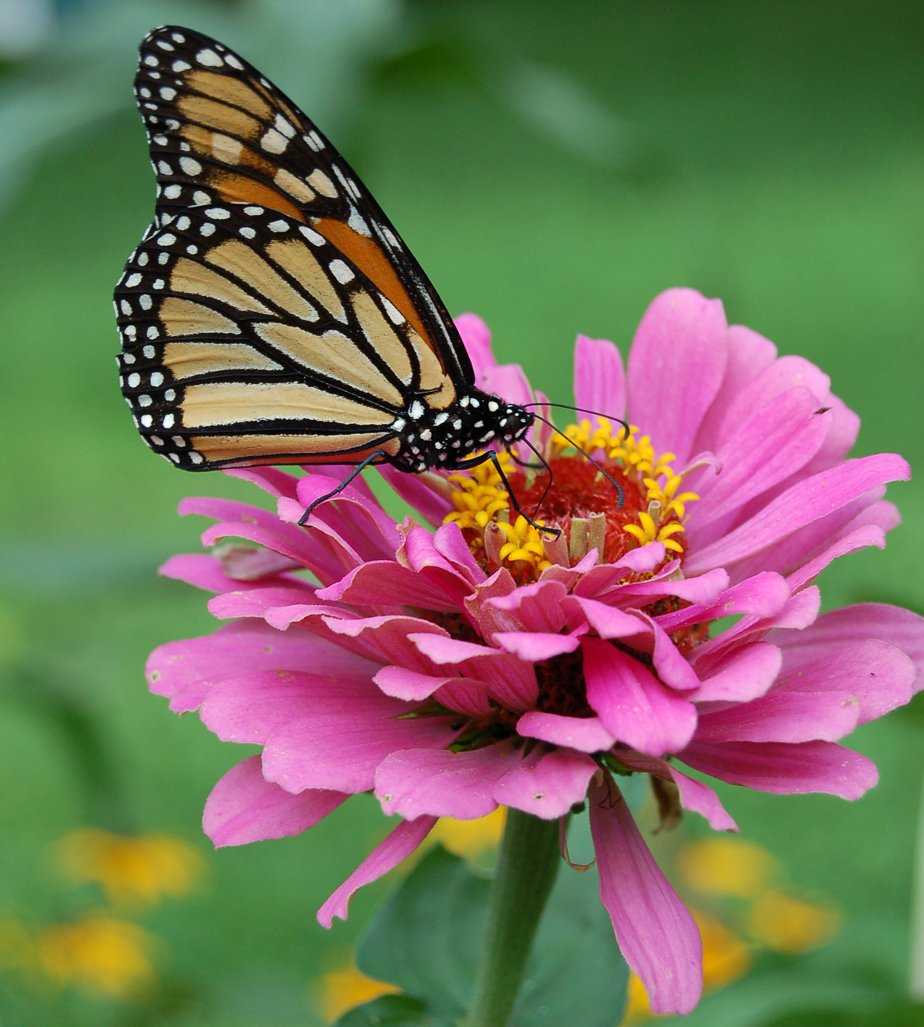Aqua aerobics will be returning in June! Potential locations include Lake Morey in Fairlee, Lake Fairlee in Thetford, and Tickle Naked in Ryegate. If you have any ideas for locations for classes land or water email me your thoughts.

PO Box 13 Piermont, NH 03779
Website: www.bizzybodies.fitness Brandi: (603) 728-8655
Email: bizzybodiesfitness@gmail.com
bizzyjoejoe@gmail.com Joseph: (802) 299-7932
Dear Bizzy Bodies Participants,
Happy Spring!! We finally made it through the New England winter weather and now we patiently (or not) wait for the arrival of warmer weather. What excites me most about spring is it represents a new beginning. Flowers are blooming, leaf buds are forming on the trees, and song birds are once again welcoming us to a new day. It is all reminiscent of great things to come. Your greatness included, whether it be working on your fitness goals from New Year’s or setting new ones for the summer we are here to help you reach your aspirations and beyond.
What’s buzzin’ with BBF?? We have kept the expanded winter class schedule through the spring. Chances are high we have a class near your community. Check out the schedule listed in this newsletter. We are also planning ahead for the summer with fitness classes outside including the return of aqua aerobics and hopefully with new locations! The walking group will be revitalized very soon and monthly themed challenges are coming back beginning in May! Lots to look forward to.
We hope that you will stop by to see Joe and me for a class. See our emails above to discuss personal in-home training options as well.
Have a great spring!
-Brandi
Are you looking to change up your walking routine this year? Below is a link on how to train for your first 5k walk. It’s a great way to get in some cardio and to help raise money for a charity!
https://www.verywellfit.com/beginners-5k-walk-training-schedule-3435038

Client Spotlight
Group Exercise Offerings
FUNdamentals of Fitness Workout Classes
Get a great heart pumping and strength building workout in one place! This 60-minute moderate intensity class features alternating segments of cardiovascular and resistance training exercises to keep you moving and challenge every fitness level.
Monday 5:30pm Corinth town hall
Monday 5:30pm St Barnabas church, Norwich, VT
Tuesday 5:00pm Thetford Congregational church, Thetford, VT
Thursday 4:30pm Orford Congregational church
Thursday 6:00pm Barrett Hall, Strafford, VT
Saturday 8:00am W. Fairlee town offices
Sunday 8:00am Barrett Hall, Strafford, VT
Three payment options: Check, Cash or Credit Card
$72 for full single location six week session
$130 for 10 class multi location punch card, good at any class, expires 12 wks. from date of purchase
$15 for drop in per class any location

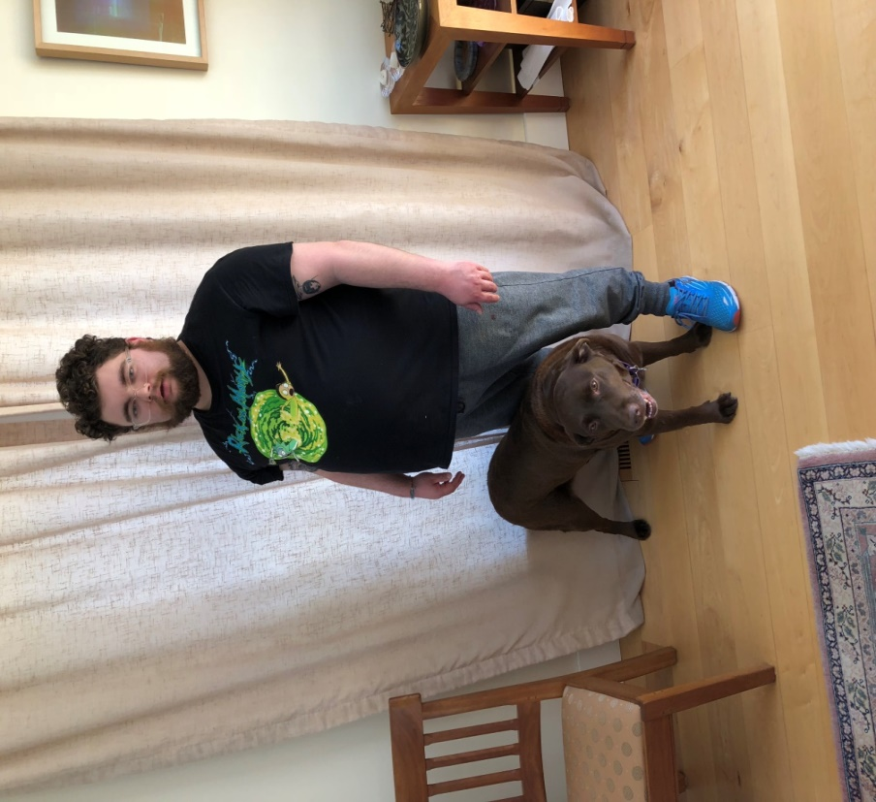
Dan and Bella, Hanover NH
- What are your fitness goals? What are you doing to work towards them? I want to lose weight and be healthy. To reach my goals, I am working out with Brandi and Joe, and on my own at the CCBA.

- In what ways have you been successful in reaching your goals? I’ve been eating better and progressively working out harder with Joe and Brandi.

- What motivates you to exercise? I want to be healthy and feel good about myself. It improves my mood, too.

- What other healthy habits do you have besides exercise that you think contributes to your successes? I eat less sugar. I work on having a good attitude about exercise.

- How long have you been working with and how would you describe your experiences with Bizzy Bodies? I’ve been working with Bizzy Bodies for about a year and it’s been wonderful. It’s fun, challenging and beneficial.

- What advice would you give to someone starting an exercise program? Don’t give up and have fun. Trust your trainer. Vary what you do to keep it interesting. Focus on being healthy.
Shrimp & Pasta with Walnut Pesto
4 oz. frozen cooked shrimp, thawed
4 oz. whole-wheat pasta, cooked according to package directions, drained
1/3 cup lightly packed baby spinach leaves
1 cup lightly packed basil leaves
2 tbsp. chopped walnuts
1 tbsp. fresh lemon juice
1 tsp. fresh grated lemon zest
1 garlic clove
2 tbsp. olive oil
2 tbsp. freshly grated Parmesan cheese
Sea salt and ground pepper, to taste
In a medium bowl, toss together the cooked shrimp and pasta. Set aside.
In the bowl of a food processor, add the spinach, basil, walnuts, lemon juice and lemon zest. Pulse to chop finely. With the machine running, add the garlic until finely minced. Scrape down the bowl and add the olive oil in a thin stream.
Scrape down the bowl and transfer basil mixture to a serving bowl. Stir in the cheese and salt and pepper, to taste.
Add 2 tablespoons of pesto to the shrimp and pasta mixture, toss lightly and serve. Refrigerate remaining pesto for later use.
*Yields eight tablespoons of pesto. Keep the remainder covered and refrigerated for topping chicken, fish, vegetables or pasta.
Nutrients per serving: Calories: 380, Total Fats: 13 g, Saturated Fat 2 g, Trans Fat: 0 g, Cholesterol: 230 mg, Sodium: 375 mg, Total Carbohydrates: 32g, Dietary Fiber: 6 g, Sugars: 1 g, Protein: 36 g, Iron 2 mg
Ready in 20 minutes.
Makes 1 serving
*Oxygen Magazine

